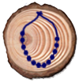
Class Bead Necklaces
Every day your instructor will give you class beads
to put on a necklace, but you've got to earn them.
Here's how:

- Follow all the High Trails rules
- Follow all of your instructor's rules
- Participate in the activities
- Have a positive attitude
- Be courteous and helpful

Check off beads as you earn them and write down each color.

 | IN THE FIELD | COLOR
 | Adventure Course
 | Archery
 | Climbing
 | Earth Works
 | Environmental Awareness
 | Feathered Friends
 | Furry Friends
 | Little World
 | Native Culture
 | Orienteering
 | Outdoor Survival
 | Plant Detectives
 | Summits
 | Team Discovery
 | Water Wonders

IN THE CABINS
Astronomy
Campfire
Hopping Bead
Nocturnal Nation
Snakes/Dance
Special Bead
Tribes

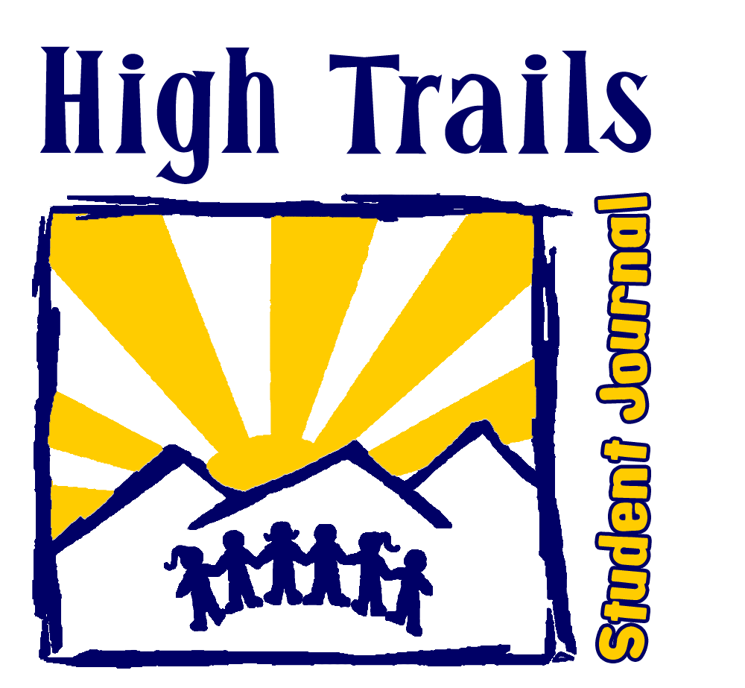

I long to be amongst the trees
tall sentinels of forest life
standing tirelessly through our generations
judging us not yet hoping for someone who learns
- unknown

Name: | School:
Favorite Animal: | Favorite Plant:
I like nature because:
notes

notes

My Daily Journal

Day 1
________________________________________________________________________________________________________________________________________________________________________________________________________________________________________________________________________________________________________________________________________________________________________________________________________________________________________________________________________________________________________________________________________________________________________________________________

Day 2
________________________________________________________________________________________________________________________________________________________________________________________________________________________________________________________________________________________________________________________________________________________________________________________________________________________________________________________________________________________________________________________________________________________________________________________________

Day 3
________________________________________________________________________________________________________________________________________________________________________________________________________________________________________________________________________________________________________________________________________________________________________________________________________________________________________________________________________________________________________________________________________________________________________________________________

Day 4
________________________________________________________________________________________________________________________________________________________________________________________________________________________________________________________________________________________________________________________________________________________________________________________________________________________________________________________________________________________________________________________________________________________________________________________________

Day 5
________________________________________________________________________________________________________________________________________________________________________________________________
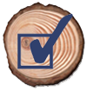
High Trails Preparation
How did you feel when you first learned you were
headed up to High Trails?

What did you do to prepare for your overnight trip?

Did your parents give you any advice or suggestions about your trip?

What do you think the best thing about this week will be? The hardest thing?

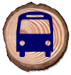
Arrival at High Trails
How was the bus ride? Who did you sit with on the bus?

What was the coolest thing you saw on the bus ride?

Who was the first instructor you met? What did they talk about?

What is your biggest goal for the week at High Trails?

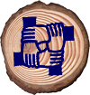
adventure course
What was your favorite activity of the adventure course?
Why?

What was the most difficult activity on the adventure course? Why?

Who helped you during the adventure course? How?

Who did you help? How?

What are 2 things your team did to be successful at the activities?
1.
2.
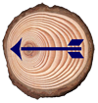
Archery
Why did the Serrano and other Native Americans use
the bow and arrow?

List 2 reasons why people use the bow and arrow today.
1.
2.
There are many safety precautions that must be taken when participating in archery. What are 2 of the rules you learned?
1.
2.
Label the ARROW below using the following 5 terms:

Tip | Shaft | Fletching | Odd Flight | Nock

Cabin
Who is your Cabin Instructor?

Who are the other people in your cabin?

What was your favorite part about cabins this week?

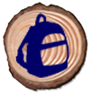

Field
Who is your Field Instructor?

Who are the other people in your field group?

What was your favorite part about being outside this week?

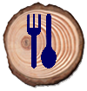
Meals
What did you enjoy most about the dining hall?

What food did you eat that you do not usually have at home?

What was your favorite meal?

Where was your favorite place that you ate lunch on the trail?

What is food waste?

Nocturnal nation
What does it mean for an animal to be:
Nocturnal:
Diurnal:
Crepuscular:
How do nocturnal animals use the following adaptations?
- Echolocation?
- Asymmetrical Hearing?
- Extra “rods” in their eyes?
What are some nocturnal animals in the San Bernardino National Forest?

Describe what you saw, heard, or identified as signs of any nocturnal animals?:

Experiment: Solo Walk
How was walking in the forest at night different than during the day?

Describe how you felt as you walked in the dark by yourself.
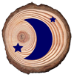

Astronomy
Name four different objects you can find in our galaxy.
- 1.
- 2.
- 3.
- 4.
Why are you able to see so many stars at camp, but not at home?

Why is the sun important to life on earth?

What is the difference between a meteor, meteoroid, and a meteorite?

Experiment: Eye To The Sky
What did you observe through the telescope or the star gazers?

How does a telescope help you see objects in the night sky?

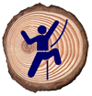
Climbing
What was your goal for the climbing wall?

How did you feel while you were on the climbing wall?

Who encouraged you and who was the most helpful?

Name 2 pieces of safety equipment used in climbing:
1.
2.
What 2 questions did you ask BEFORE climbing the wall?
1.
2.
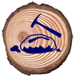
Earth Works
Use Elements, Minerals, and Rock to fill in the blanks:
A ____________ is a collection of _______________
that are formed by ____________________.
What are the 2 types of weathering?
1.
2.
What are the 3 major classifications of rock?
1.
2.
3.
Ores and gems can be very valuable. Why?

Experiment: Breaking Rocks
How does the inside of your rock look as compared to the outside?

Was your rock easy or hard to break?
What does that tell you about how it was formed?

Environmental Awareness
What is the difference between renewable and
nonrenewable resources? Give an example of each:

What are the natural origins of the materials used in your school pencil?

What about your television?

List 2 Alternative Energy Sources:
1.
2.
What small changes could you make at home to help out the Earth?

Experiment: The Oil Game
What happens when people do not have the resources they need to survive?

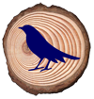

Feathered Friends
What types of birds were you able to identify?
Did you identify them by sound or sight?

What are 2 examples of bird adaptations?
1.
2.
Explain the difference between downy and contour feathers. Draw them both:

Why do birds have different shaped beaks?

Experiment: Deadly Links
How does pollution affect the food chain and web for birds?

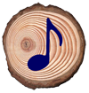
Line Dancing
Who led your line dances?

What did you like the most about dancing?

What can dancing teach you about life?

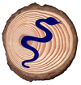
Snakes
List two adaptations that snakes have.
1.
2.
Who was your favorite snake? Why?

How did it feel to touch the snakes?

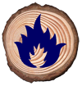

Campfire
What was your cabin’s skit called? What was it about?

What was your favorite skit?

What was your favorite song that you learned this week?

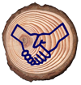

Tribes
What was your favorite Tribes activity? Why?

Which activities helped you find commonalities with other people in your cabin?

Why do you think it was important to have tribes?
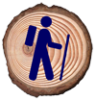
Team Discovery Hike
Who is in your Field Group?

Name 2 Rules/Expectations from your Field Group's group contract.
1.
2.
What did you learn today about working with your group?

Who are the Serrano Indians?

All living things have the same basic survival needs. These factors are:
F: | W: | A: | R: | P: | S:
Experiment: Turnstile
What are some important skills your team should use this week?

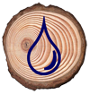

Water Wonders
What percentage of the Earth is Water?_______%
What percentage is usable for drinking?_______%
Circle 6 words below that are part of the water cycle:

Evaporation | Conduction | Rundown | Evacuation
Precipitation | Consideration | Runaround | Percolation
Condensation | Transpiration | Observation | Runoff

Name 2 Sources of Drinkable Water?
1.
2.
Name 2 Types of water Pollution
1.
2.
Experiment : Groundwater
Since water percolates through the soil, what will happen to the groundwater if pollutants is in the soil?

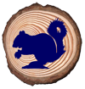
Furry Friends
What makes a mammal distinct from other animals?

Define Adaptation:

Name 2 mammals in our forest and how they adapt to their environment:
1.
2.
List the 3 categories of mammal consumers:
H: | O: | C:
Experiment: Oh Deer
When a forest cannot support the deer what are some things that happen to the animals and resources within it?

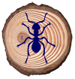

Little World
What is the purpose of the nitrogen cycle?

What does mimicry mean? How might an insect use mimicry?

What living things (FBI’s) help with decomposition?
F: | B: | I: | S:
Give an example of an adaptation an insect has developed:

Experiment: FBI Hunt
What evidence of FBI’s did you see in the forest?

Was it easy or difficult to find FBI’s? Why?

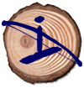
Native culture
Why was oral tradition very important to the Serranos?

For what purposes did the Serranos use the following resources?
- Manzanita leaves:
- Willow Branches:
- Acorns:
Explain the process of using a mano and metate.

Why is fire such a vital element to human survival?

Experiment: Bow Drill Fire
How does the bow drill set create fire?

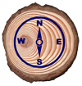
Orienteering
How many degrees are on the dial of a compass?

Using the compass on the right, note the degrees next to
each direction of North, East , South and West:
Write in the word below that fits for each definition:
Topographic Map | Map Legend | Map Scale
Countour Line | Orienteering | Elevation
___________: How high a place is above sea level
___________: Using a map and compass to determine location and/or Direction
___________: A line on a topo map that connects point at the same elevation
___________: A way to compare distance on a map to real life distance.
___________: A table of symbols used on a map
___________: A map that shows features of earth’s surface as a pattern of lines.
Experiment: Find Your Way
Were you able to complete your color course? Why or why not?

What did the signs spell out for you?

How can you use Orienteering in the future?

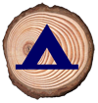
Outdoor Survival Hike
Name 3 of the 10 items that are essential to take on a hike:
1.
2.
3.
What does S.T.O.P. stand for in a survival situation?
S: | T: | O: | P:
The rule of 3’s helps you prioritize your needs when in a survival situation. Finish each sentence below.
I can live 3 seconds without ________ I can live 3 minutes without__________
I can live 3 hours without __________ I can live 3 days without ____________
I can live 3 weeks without _________ I can live 3 years without homework
Experiment: Build A Shelter
What resources did you use to construct your shelter?

How can you make a shelter waterproof, windproof, and insulated?

Plant Detectives
Trees and plants are called producers. Why?

Changing energy from sunlight into chemical energy is called what?

What is the role that Plants/Trees have within their environment?

What is the difference between an evergreen and a deciduous tree?

Name 2 animals that help plants and trees with either pollination or seed dispersal:
1.
2.
Experiment: Acid Rain
What causes Acid Rain?

What can you do to prevent/reduce pollution?

